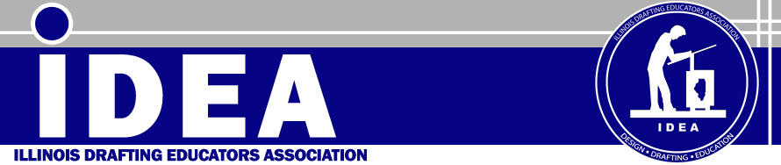

Dear IDEA Members,
Well after an exceptional workshop and joint Friday conference with the Technology Education Association of Illinois, I hope all of you that attended are getting some well deserved rest. I have been a member of IDEA for close to twenty years and in that time the drafting profession and how we teach drafting has really changed dramatically. I am not a dinosaur, but could be, and I do keep up with technology, however, today I received an email in regards to being able to access my Blackboard web course on my Blackberry (as if I would want to). As an organization we must start to set some goals and look at the direction that we need to pursue in order to encourage membership growth and how we can assist our membership in their profession.
Some of the items that the IDEA Executive Board and the Competition Directors have changed this year are the elimination of the mechanical board competition at the regional and State competitions in favor or a computer assembly competition. We have for the past two years combined our Friday conference with the ITEC/TEAI conference. However, as a organization we do wish to get feedback from our membership on how they like that format, we will be contacting you as to how that format works for you or you can email any of the members of the board to provide us feedback which our plans to discuss at the February meeting. I hope to also move in a direction of providing some teaching resources and best practice materials on our website this year to attract new members and assist current members with their classes.
I hope everyone has a great year in preparing our students for further educational endeavors or entry into the workforce. Thank you all for your participation at our workshops, conference and competitions. I look forward to seeing you at the IDEA State competition in Bloomington.

Cheers,
Kevin Weston
President- Illinois Drafting Educators Association
Professor- Architectural Technology
Rend Lake College

